One Monkey Two Cats

In a village a monkey was live in a house. That monkey was hungry. That monkey ask with his mother, I go find food to eat. His mother said okay. That monkey go find food time there was two cats fighting for the one Chapati. That monkey jump and take the one Chapati and run to his house. The two cats so sad and went to they house.

Moral of story: Do not fight
Written by : Mr Andrew Rayshaan

1 | One Monkey | 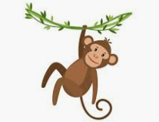
2 | Two Cats | 

