MY SELF

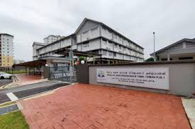
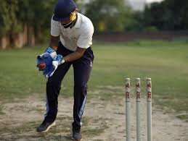
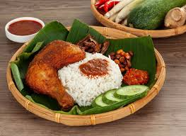

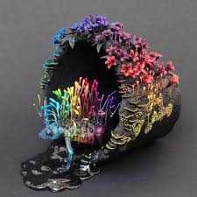

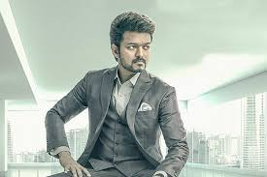
HI MY NAME IS HOVIEN DARSHAN .IM 12 YEARS OLD .I STUDY AT SJKT PJS1 .MY FAVOURITE SPORTS IS CRICET .AND I AF PLAY CRICET FOR MY SCHOOL AS WICKET KEAPER.I LOVE TO COOK.MY AMBITION IS BECOMING A CHEF .MY HOBI IS DOING CREATIVE THINGSC.I LOVE PUPPY. .VIJAY IS MY DREAM

