The Goat Called Willow

In a far forest there was a goat called Willow. Willow was a funny little goat. He was running around in the forest. The forest has so many tree’s and animals like monkey’ tiger and elephant. He has so many friend’s. One day Willow was drinking some water in the lake in that time a large bear was standing near him asking some food from the goat. He was shaking at that moment and was listening to the bear. The bear asked the goat to bring me a fish and berries. The goat brought what did the bear said to him. When he was giving the food the goat was nervous. In that time a small girl and her father. They was setting up a picnic near the forest so the goat went up to them and said baa’ baa. The girl thought the goat was hungry but no the goat in danger the girl understood the situation and came with him to the forest… THE END
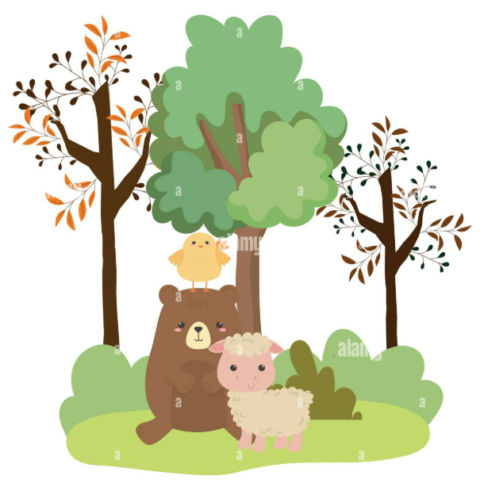
written by sahasra

